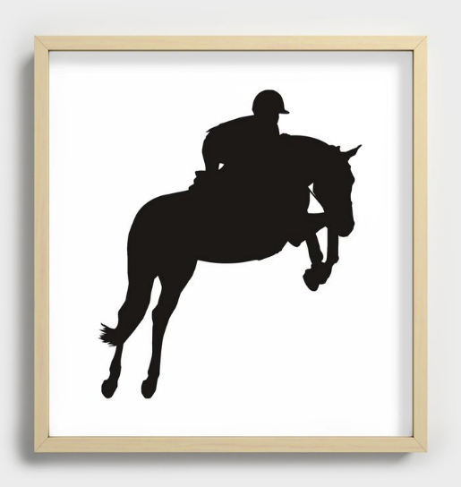

***Established 1994***

**Blue & Gray Horse Shows**

**2025 Membership Form**

**Name** __________________________________________________**Date of Birth**___________________

**Address**______________________________________________________________________________

**City** ___________________________________________**_State**_________________________________

**Zip** _________________**Phone** #_____________________**E-Mail**________________________________

**Please Mark the Type of Membership: ____Single $25.00 ____ Family $35.00**

**If a Family membership please list the names and ages of other Riders included with your membership.**

**Name**__________________________________________________**_Date of Birth**_______________________

**Name**___________________________________________________**Date of Birth** _______________________

**POINT COUNT STARTS AS SOON AS THE RIDER AND HORSE IS NOMINATED**

Trainer_______________________________________________________________________________

**Nominated Horse (1st horse is free with a single or family membership)**

Horse's Name _________________________________________________________________________

Age____________Height_______________Color_____________________Amount $ Free ___________

**Additional Nominated Horse(s) at $5.00 per horse**

Horse's Name _________________________________________________________________________

Age____________Height_______________Color_____________________Amount $ 5.00

Horse's Name _________________________________________________________________________

Age____________Height_______________Color_____________________Amount $ 5.00

|  |
| --- |
| Make checks payable to the Blue & Gray Horse Shows.  **Forms can be mailed to: Lori Swanson, 2246 Newville Road Carlisle PA 17015**  **Office Use Only: Date Membership Recorded ________/_________/2025** |